**PriceSavvy: Intelligent Price Comparator**

A **Project Report**

Submitted in partial fulfilment of the requirements for the

**Award of the degree of**

**“Master of Computer Application”**

**By**

**Aastha Mishra**

**(321200646)**



**Centre for Distance and Online Education**

**LOVELY PROFESSIONAL UNIVERSITY**

**PHAGWARA, PUNJAB**

**2024**

**Table of Contents**

|  |  |  |
| --- | --- | --- |
| **S. No.** | **Title** | **Page** |
| **1** | Declaration by Student |  |
| **2** | Acknowledgement |  |
| **3** | Abstract |  |
| **4** | Chapter-1 Introduction |  |
| **5** | Chapter-2 Review of Literature |  |
| **6** | Chapter-3 Implementation of project |  |
| **7** | Chapter-4 Results and Discussions |  |
| **8** | Final Chapter- Conclusion and Future Scope |  |
| **9** | Publication details |  |
| **10** | Annexures |  |
| **11** | References |  |

**Annexure-III**

**Declaration by the Student**

**To whom-so-ever it may concern**

I, Aastha Mishra, 321200646, hereby declare that the work done by me on “**PriceSavvy: Intelligent Price Comparator**”, is a record of original work for the partial fulfilment of the requirements for the award of the degree, Master of Computer Application.

Aastha Mishra (321200646)

Signature of the student

Dated:

**Acknowledgement**

I want to express my heartfelt thanks and deep appreciation to everyone who played a pivotal role in the successful culmination of my MCA project. This project has been an enriching experience, and I am indebted to the following individuals and entities:

1. Nilesh Muley: I extend my heartfelt thanks to Nilesh Muley, my project supervisor, for their guidance, valuable insights, and unwavering support throughout the project. Their expertise and mentorship have been invaluable in shaping the project's required skills direction and outcomes.

2. Deloitte USI: I am grateful to Deloitte USI for providing me with the opportunity to undertake the tool skills required for this project within the organization. The exposure to real-world challenges and access to resources have been instrumental in enhancing my skills and knowledge.

3. Anusuya Sarkar, Debiprasanna, Lipsita and LPU Mentors: I would like to thank my colleagues and team members at Cleco Robotic Process Automation Project in the firm for their collaboration, assistance, and encouragement. Their collective efforts have significantly contributed to the success of the skill that I learnt and used to implement this project.

5. Family and Friends: Lastly, I want to express my appreciation to my family and friends for standing by me with unwavering encouragement, understanding, and patience during the course of this project. Their emotional support has been a source of motivation and strength.

This project has been a journey of growth and learning, and I am fortunate to have had the support of such wonderful individuals and organizations. Thank you all for being an integral part of this endeavor.

**Abstract**

In the rapidly evolving landscape of business process automation, this Master of Computer Applications (MCA) project leverages UiPath to streamline and enhance the efficiency of price comparison for products across e-commerce platforms. The primary focus is on automating the process of obtaining product prices from prominent online retailers, namely Amazon, Flipkart, and JioMart, through user-inputted product names. The automation process culminates in the extraction and organization of relevant details into an Excel spreadsheet for further analysis.

The project begins with the user providing a product name, initiating a sequence of robotic processes orchestrated by UiPath. The software interacts with each e-commerce platform, extracting the current prices for the specified product. The extracted information is then systematically recorded in an Excel sheet, facilitating easy comparison and analysis.

**The key components of the project include:**

**1. User Input and Interaction:**

* Designing an intuitive interface for users to input the desired product name.
* Implementing UiPath activities for capturing user input and processing requests.

**2. Web Scraping and Data Extraction:**

* Utilizing UiPath's web scraping capabilities to extract product prices from Amazon, Flipkart, and JioMart.
* Implementing error handling mechanisms to ensure robustness in data extraction.

**3. Data Comparison and Analysis:**

* Developing algorithms for comparing prices across different platforms.
* Implementing logic to identify the best price and relevant insights.

**4. Excel Automation:**

* Employing UiPath activities to dynamically populate an Excel spreadsheet with the extracted product details.
* Ensuring data integrity and organization within the Excel sheet.

The outcome of this project is an automated solution that significantly reduces the time and effort required for price comparison across multiple e-commerce platforms. By harnessing the power of UiPath, the project exemplifies the practical application of robotic process automation in enhancing decision-making processes for consumers.

This MCA project serves as a testament to the potential of UiPath in optimizing routine tasks, improving data accuracy, and contributing to the advancement of business processes in the era of digital automation.

**Chapter-1: Introduction**

**Aim:** The aim of the automation is to streamline and automate the process of collecting item rates from different websites, allowing for efficient and accurate comparison. The primary objective is to reduce manual effort and potential errors associated with the manual retrieval of information from multiple sources.

**Importance:**

1. **Efficiency**: Automation increases efficiency by eliminating repetitive tasks, enabling human resources to concentrate on intricate and value-enhancing tasks.

2. **Accuracy**: Automation minimizes the likelihood of errors associated with manual data entry or information retrieval, ensuring more reliable and accurate results.

3. **Time** **Savings**: The automated process can perform tasks much faster than a human, leading to considerable time savings in the data collection and comparison process.

4. **Consistency**: Automation ensures consistency in data collection and formatting, as the process is standardized and follows predefined rules.

**Applicability**:

1. **Price** **Comparison**: The automation is particularly applicable in scenarios where the user needs to compare prices of a specific item across multiple websites or platforms.

2. **Market Research**: It can be used for market research purposes to gather pricing information for competitive analysis.

3. **Decision Support**: Users can make more informed decisions based on the comprehensive comparison of prices gathered from various sources.

**Scope**: The scope of this UiPath automation includes:

1. **User** **Interaction**: Taking input from the user regarding the item for which prices need to be compared.

2. **Web Scraping**: Extracting price information from different websites.

3. **Data Processing**: Storing and processing the retrieved data for meaningful comparison.

4. **Excel Integration**: Populating an Excel sheet with the collected data for easy visualization and analysis.

**Relevance:**

1. **Competitive Analysis**: In business, the ability to compare prices quickly and accurately from different sources is crucial for staying competitive.

2. **Cost Savings**: By automating the data collection and comparison process, organizations can save costs associated with manual labor.

3. **Decision-making Support**: The automation provides valuable data for decision-making processes, aiding users in choosing the most cost-effective option.

4. **Adaptability**: The automation can be adapted to different industries and scenarios where the comparison of information from various sources is essential.

**Chapter-2: Review of Literature**

**Introduction to Robotic Process Automation (RPA):** The transformation of the global economy, propelled by advancements in technology, mandates businesses to enhance their adaptability and promptly address the needs, desires, and requests of their clientele. Furthermore, the compelling influence of competition and financial constraints compels organizations to bolster their efficiency, continually exploring innovative technologies and methodologies to bolster productivity, cut costs, and augment business value. A notable solution emerging as a technological breakthrough is robotic process automation (RPA), offering the capacity to substitute human efforts in routine tasks, automating them, and thereby empowering employees to engage in more intricate assignments that contribute greater value to the organization. Consulting reports underscore RPA as a burgeoning and disruptive technology that is already yielding substantial benefits.

**History and Evolution of UiPath:** Robotic Process Automation (RPA) involves automating repetitive and rule-based tasks through non-invasive software robots, commonly referred to as 'bots.' Recently, RPA has expanded its definition to include integration with artificial intelligence (AI), cognitive computing, process mining, and data analytics. Advanced digital technologies have empowered RPA to transition from handling routine business processes to undertaking more complex, knowledge-intensive, and value-adding tasks.

**Explore the founding of UiPath and its initial goals:**

UiPath has evolved significantly since its inception. The company was founded in 2005 by Daniel Dines and Marius Tirca, and its journey reflects the broader evolution of the Robotic Process Automation (RPA) industry. Here is a brief overview of the evolution of UiPath:

**1. Foundation (2005-2012):** UiPath was founded in Romania in 2005 as DeskOver, later becoming Softomotive in 2010. Initially, it focused on developing desktop automation solutions.

**2. Shift to RPA (2012-2014):** In 2012, UiPath pivoted towards Robotic Process Automation, recognizing the potential for automation beyond individual desktop tasks. This shift laid the foundation for its RPA platform.

**3. Early RPA Platform (2015-2017):** UiPath released its early versions of the RPA platform, allowing organizations to automate business processes. During this period, the company started gaining recognition in the emerging RPA market.

**4. Growth and Market Recognition (2018):** UiPath experienced rapid growth and gained significant market recognition. The company secured substantial funding, and its RPA platform became widely adopted by enterprises for automating repetitive tasks.

**5. Becoming a Unicorn (2018):** In early 2018, UiPath achieved "unicorn" status, indicating a privately held startup valued at over $1 billion. This highlighted the company's success and the growing importance of RPA in the tech industry.

**6. IPO Preparation (2020-2021):** UiPath filed for an initial public offering (IPO) in 2020. The company went public on April 21, 2021, on the New York Stock Exchange (NYSE) under the ticker symbol "PATH." The IPO marked a significant milestone in UiPath's journey.

**7. Post-IPO Developments (2021-2022):** Following the IPO, UiPath continued to expand its offerings and enhance its platform. The company aimed to capitalize on the increasing demand for automation solutions in various industries.

**8. Integration of AI and Cloud (Ongoing):** UiPath continues to evolve by integrating artificial intelligence (AI) capabilities into its platform. Additionally, there is a focus on cloud-based solutions, reflecting industry trends toward cloud adoption for greater flexibility and scalability.

**9.** **Community and Ecosystem Growth:** UiPath has fostered a vibrant community of developers and users contributing to its ecosystem. The growth of the UiPath community has played a crucial role in the platform's evolution, with developers creating and sharing automation solutions.

**Discussion on mergers, acquisitions, or strategic partnerships that have shaped UiPath's trajectory-**  UiPath has engaged in several strategic moves, including acquisitions and partnerships, to enhance its capabilities, expand its market reach, and stay competitive in the rapidly evolving field of Robotic Process Automation (RPA). Keep in mind that developments may have occurred after this date. Here are some notable mergers, acquisitions, and partnerships involving UiPath:

**1. ProcessGold Acquisition (2019):** UiPath acquired ProcessGold, a process mining company, in 2019. This acquisition strengthened UiPath's capabilities in process understanding and analytics. ProcessGold's technology allowed UiPath users to gain insights into their workflows and identify areas for automation.

**2. StepShot Acquisition (2019):** UiPath acquired StepShot, a provider of Process Documentation software, in 2019. This acquisition aimed to enhance UiPath's documentation capabilities, making it easier for users to document and understand their automated processes.

**3. Cloud Elements Partnership (2019):** UiPath entered into a strategic partnership with Cloud Elements in 2019. This collaboration focused on providing advanced API integration capabilities to UiPath users, facilitating the integration of various applications and data sources in their automation workflows.

**4. 360Learning Integration (2020):** UiPath integrated with 360Learning, a collaborative learning platform, in 2020. This integration aimed to enhance the training and learning aspects of UiPath's Automation Cloud, enabling users to upskill and leverage automation more effectively.

**5.Moveworks Integration (2020):** UiPath integrated with Moveworks, an AI-powered support platform, in 2020. This integration allowed UiPath to enhance its customer support capabilities by leveraging AI-driven automation for issue resolution and support services.

**6. Devpost Hackathon Platform Acquisition (2020):** In 2020, UiPath acquired Devpost, a platform that connects companies with developers through hackathons. This move was part of UiPath's efforts to strengthen its community engagement and encourage the development of automation solutions by providing a platform for collaboration and innovation.

**7. Cloudsmith Partnership (2020):** UiPath partnered with Cloudsmith in 2020 to enhance its automation capabilities in managing and distributing automation assets. This collaboration aimed to improve the efficiency of deploying and scaling automation solutions.

**8. Strategic Partnership with AWS (2020):** UiPath entered into a strategic partnership with Amazon Web Services (AWS) in 2020. This collaboration focused on integrating UiPath's RPA platform with AWS cloud services, providing users with enhanced scalability, security, and flexibility.

**9. Strategic Partnership with Microsoft (2020):** UiPath strengthened its partnership with Microsoft in 2020 to integrate its RPA platform with Azure, Microsoft's cloud computing service. This collaboration aimed to provide seamless automation capabilities for users leveraging Azure cloud resources.

In 2021, UiPath acquired Cloud Elements and gained access to AI integration technology.UiPath has also pursued strategic partnerships, including one with [data and analytics vendor Alteryx](https://www.techtarget.com/searchbusinessanalytics/news/252518483/Alteryx-adds-augmented-analytics-more-cloud-capabilities).

**Role of UiPath Orchestrator in managing and monitoring automation processes-** UiPath Orchestrator is a web-based platform designed to manage, monitor, and deploy UiPath robots at scale. It plays a crucial role in orchestrating and overseeing automation processes, providing centralized control and visibility into the entire automation infrastructure. Here are the key aspects of UiPath Orchestrator's role in managing and monitoring automation processes:

**1.Robot Deployment and Management:**

**Centralized Robot Management:** Orchestrator allows for the centralized management of UiPath robots. It provides a dashboard where administrators can view and manage all connected robots in the automation environment.

**Robot Provisioning and Configuration:** Orchestrator enables the provisioning and configuration of robots, allowing administrators to allocate specific robots to perform particular tasks and configuring their runtime settings.

**2.Process Automation Deployment:**

**Package Deployment:** Orchestrator facilitates the deployment of automation packages (workflows) to robots. This ensures that the latest versions of automation processes are available for execution.

**Environment Configuration:** Automation processes can be associated with specific environments, allowing for the organization of robots based on their roles or responsibilities.

**3. Scheduling and Triggers:**

**Process Scheduling:** Orchestrator enables the scheduling of automation processes, allowing administrators to define when specific processes should run. This feature is crucial for automating routine tasks at specific times or intervals.

**Trigger-Based Execution:** Automation processes can be triggered based on specific events, such as the completion of a preceding task, the arrival of new data, or external system events. Orchestrator allows the creation of triggers to initiate processes based on predefined conditions.

**4.Monitoring and Logging:**

**Real-time Monitoring:** Orchestrator provides real-time monitoring of robot activities. Administrators can view the status of ongoing processes, monitor the performance of individual robots, and identify any issues or errors.  
**Logging and Audit Trails:** Orchestrator maintains detailed logs and audit trails for each executed process. This logging capability is essential for troubleshooting, compliance, and auditing purposes. It captures information about each step of the automation process.

**5. Job Queues and Prioritization:**

**Job Queues:** Orchestrator supports the concept of job queues, allowing administrators to organize and prioritize automation tasks. This is particularly useful in scenarios where multiple processes need to be executed, and their order or priority is crucial.

**Prioritization and Dependencies:** Orchestrator enables the prioritization of jobs and the definition of dependencies between different automation processes. This ensures that critical tasks are executed first, and subsequent tasks are scheduled accordingly.

**6. Security and Access Control:**

**User and Role Management:** Orchestrator includes robust user and role management features. Administrators can define roles and permissions for different users, ensuring that only authorized individuals can access and control specific aspects of the automation infrastructure.

**Secure Credential Storage:** Orchestrator provides a secure vault for storing credentials used in automation processes. This enhances security by centralizing and encrypting sensitive information.

**7. Scalability and High Availability:**

**Scalability:** Orchestrator is designed to scale with the growing automation needs of an organization. It supports the management of a large number of robots and processes, allowing for seamless scalability.

**High Availability:** Orchestrator can be configured for high availability, ensuring continuous operation even in the case of server failures. This is crucial for maintaining the reliability of automation processes.

**8. Alerts and Notifications:** Orchestrator can be set up to issue alerts and notifications in response to predefined events or conditions. This feature ensures that administrators are promptly informed about any issues that require attention.

**Discussion UiPath's support for a variety of applications and platforms, including web, desktop, and Citrix environments-**

UiPath is renowned for its versatility in automating a wide range of applications and platforms, demonstrating a comprehensive capability to address automation needs across diverse environments. Here's an overview of UiPath's support for various applications and platforms, including web, desktop, and Citrix environments:

**1.Web Automation:**

**Web Scraping and Data Extraction:** UiPath provides specialized activities for web scraping, enabling the extraction of data from web pages. It supports various web technologies, including HTML, JavaScript, AJAX, and others.

**Browser Automation:** UiPath supports automation across popular web browsers such as Chrome, Firefox, Edge, and Internet Explorer. It allows interaction with web elements, form filling, and navigation within web applications.

**Web Automation Recording:** UiPath Studio features a web recorder that simplifies the automation of web-based tasks. It captures user interactions with web elements, generating automation workflows.

**2. Desktop Automation:**

**Application Interaction:** UiPath excels in automating desktop applications, including both Windows and Java applications. It provides a rich set of activities to interact with UI elements, such as clicks, text inputs, and dropdown selections.

**Citrix Automation:** UiPath is capable of automating applications hosted on Citrix environments. It uses technologies like Citrix XenApp and Citrix XenDesktop to interact with virtualized applications, allowing for automation in virtual desktop environments.

**Win32 and WPF Applications:** UiPath seamlessly automates Win32 and Windows Presentation Foundation (WPF) applications, making it versatile in addressing a broad spectrum of desktop applications.

**3. Citrix Environment Automation:**

**Citrix Ready Certification:** UiPath is Citrix Ready certified, ensuring compatibility and optimal performance when automating processes in Citrix environments.

**Image and Text Recognition:** To navigate virtualized desktops, UiPath employs advanced image and text recognition capabilities. This allows bots to identify and interact with elements within Citrix environments.

**Citrix Automation Activities:** UiPath offers dedicated activities designed for Citrix automation, simplifying the creation of automation workflows for tasks executed within Citrix environments.

**4. OCR (Optical Character Recognition): OCR Engine Integration:** UiPath incorporates OCR engines like Microsoft OCR, Google OCR, and Abbyy OCR. This enables the extraction of text from images and scanned documents, broadening the scope of automation for processes involving non-digital inputs.

**5. Integration with Third-Party APIs: API Automation:** UiPath supports integration with various third-party APIs, allowing for seamless communication with external applications and services. This extends the range of processes that can be automated by UiPath.

**6. Mobile Automation (UiPath Mobile): Mobile App Automation:** UiPath Mobile extends automation capabilities to mobile applications on both Android and iOS platforms. It allows for the creation of automation workflows that interact with and automate processes within mobile apps.

**7. Integration with Cloud Services: Cloud Platform Integration:** UiPath supports integration with cloud platforms such as Microsoft Azure and AWS. This enables the deployment and management of automation processes in cloud environments.

**Use Cases and Applications:**

UiPath's Robotic Process Automation (RPA) platform has found applications across a wide range of industries, providing automation solutions that streamline processes, enhance efficiency, and reduce operational costs. Here are specific examples of industries benefiting from UiPath:

**1. Finance and Banking:**

**Customer Onboarding:** Financial institutions use UiPath to automate the customer onboarding process. This includes tasks such as data validation, document processing, and compliance checks.

**Invoice Processing:** RPA is employed to automate the extraction and processing of invoice data, reducing manual errors and accelerating the invoice-to-pay process.

**Fraud Detection:** UiPath assists in automating routine tasks related to fraud detection and prevention. Bots can analyze large datasets and flag suspicious transactions for further investigation.

**1.Healthcare:**

**Patient Record Management:** Healthcare organizations leverage UiPath to automate tasks related to patient record management. This includes data entry, updating electronic health records (EHR), and ensuring data accuracy.

**Claims Processing:** RPA is utilized for automating claims processing in the healthcare insurance sector. Bots can validate claims, check for discrepancies, and process payments.

**Appointment Scheduling:** UiPath is employed to automate appointment scheduling processes, improving the efficiency of healthcare facilities and ensuring accurate appointment bookings.

**2. Manufacturing:**

**Supply Chain Management:** UiPath helps manufacturers automate various aspects of supply chain management, such as order processing, inventory management, and demand forecasting.

**Quality Control:** RPA is used for automating quality control processes on the manufacturing floor. Bots can analyze data from sensors and identify deviations from quality standards.

**Invoice and Purchase Order Processing:** Automation streamlines the processing of invoices and purchase orders in manufacturing, reducing the time and effort required for manual data entry.

**3. Retail and E-commerce:**

**Order Processing:** UiPath is employed to automate order processing tasks in retail and e-commerce, ensuring timely fulfillment and reducing errors in order management.

**Inventory Management:** RPA assists in automating inventory management processes, including stock level monitoring, order replenishment, and synchronization across multiple platforms.

**Customer Support:** Bots can handle routine customer support inquiries, freeing up human agents to focus on more complex issues. This enhances the efficiency of customer service operations.

**4. Telecommunications:**

**Billing and Invoicing:** UiPath is used in the telecommunications industry to automate billing and invoicing processes, ensuring accuracy in charging and reducing billing discrepancies.

**Customer Data Management:** RPA assists in automating the management of customer data, ensuring that customer information is up-to-date and accurate across various systems.

**Network Configuration:** Bots can automate routine network configuration tasks, optimizing the management of telecommunications infrastructure.

**5. Insurance:**

**Claims Processing:** UiPath is employed to automate claims processing in the insurance sector. Bots can extract relevant information from claims forms, verify policy details, and facilitate faster claims settlements.

**Underwriting:** Automation is used to streamline the underwriting process, including risk assessment, data analysis, and policy generation.

**Policy Renewals:** RPA helps automate the renewal process for insurance policies, sending timely reminders to clients and processing renewals efficiently.

**Chapter-3: Implementation of project**

**I. Objectives:**

1. Developed an automated system using UiPath for fetching and comparing details from different websites.

2. Enables user input to customize the search parameters and items to be compared.

3. Implements a data storage mechanism to store the compared details in an organized manner.

4. Streamlines the process to enhance efficiency and reduce manual efforts.

**II. Hypothesis:**

Automation using UiPath can significantly reduce the time and effort involved in comparing details from various websites, leading to increased efficiency and accuracy in data processing.

**III. Experimental Work:**

**A. Methodology and Designing:**

**1. User Input:** A user-friendly interface designed using UiPath to input items and search parameters.

**2. Web Scraping:** Implements web scraping techniques to extract details from different websites.

**3. Data Comparison:** Developed algorithms to compare extracted data and identify variances.

**4. Excel Automation:** Utilizes UiPath activities to interact with Excel for storing and organizing compared details.

**B. Tools and Techniques:**

**1. UiPath Studio:** Develop and design automation workflows.

**2. Web Scraping Tools:** Tools used for scraping data from different websites using get text, get attributes, use application and browser, etc. activities.

**3. Excel:** Uses Excel for storing and presenting the compared details.

**C. Instrumentation:** Required Set up of UiPath Studio on development machines.

Ensures web scraping tools are configured and tested for each targeted website.

We do require to download the packages through Manage Packages required to fetch the activities for the automation. Below packages are mentioned required for the process:

* UiPath.Excel.Activities
* UiPath.Mail.Activities
* UiPath.System.Activities
* UiPath.Testing.Activities
* UiPath.UIAutomation.Activities

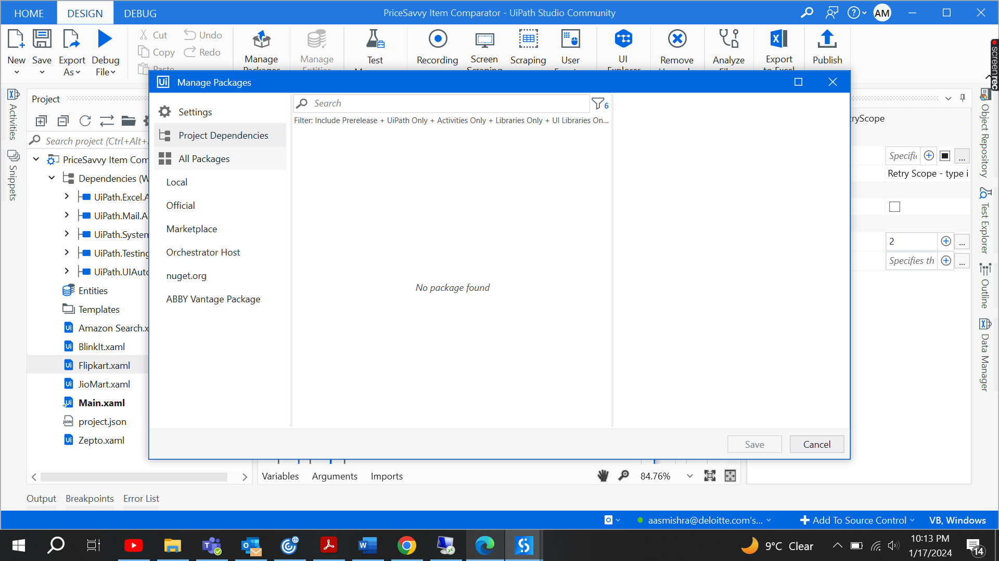

Figure 3.1

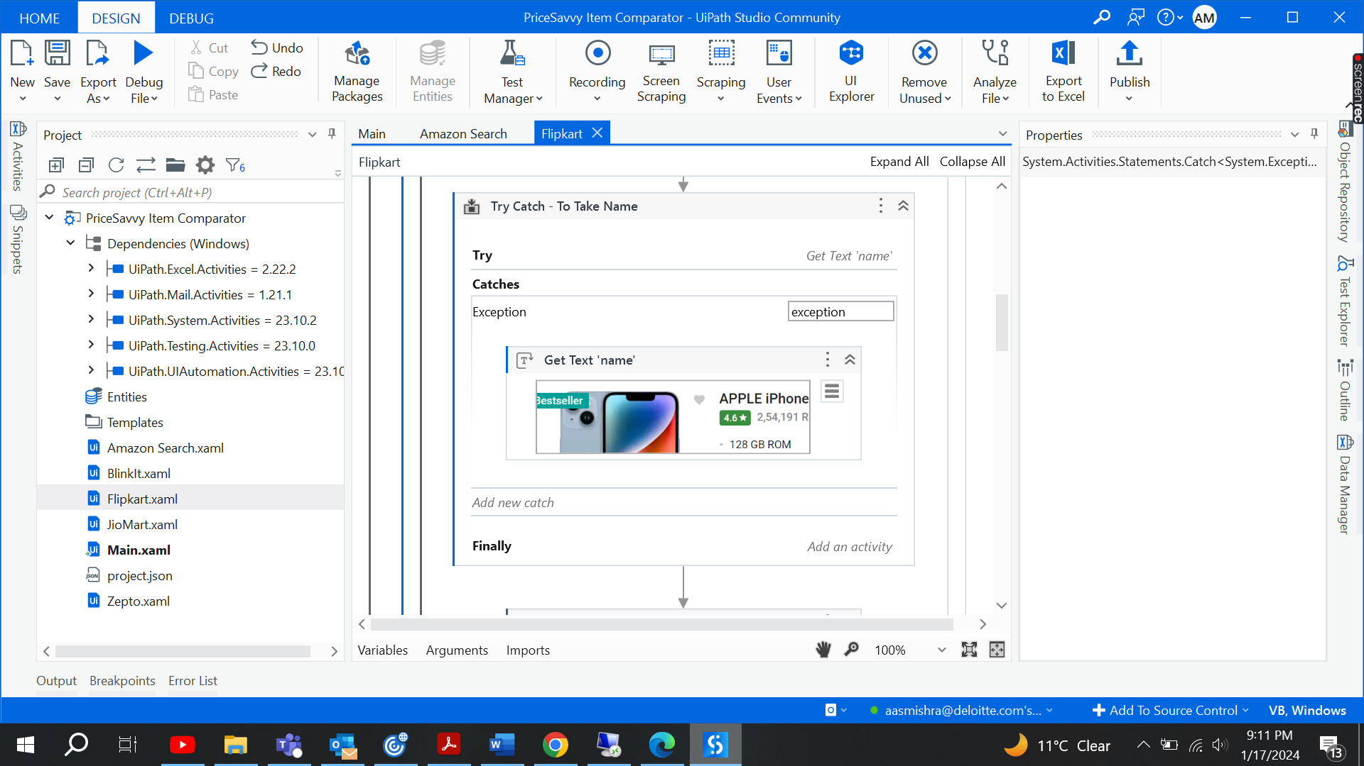

Figure 3.2

**D. Coding:** Wrote UiPath workflows for user input, web scraping, data comparison, and Excel automation. Includes error handling mechanisms to address unexpected scenarios. For the error handling we have defined few activities to handle-

**Flow Chart for the Process:**



Figure 3.3

**Main Workflow:**

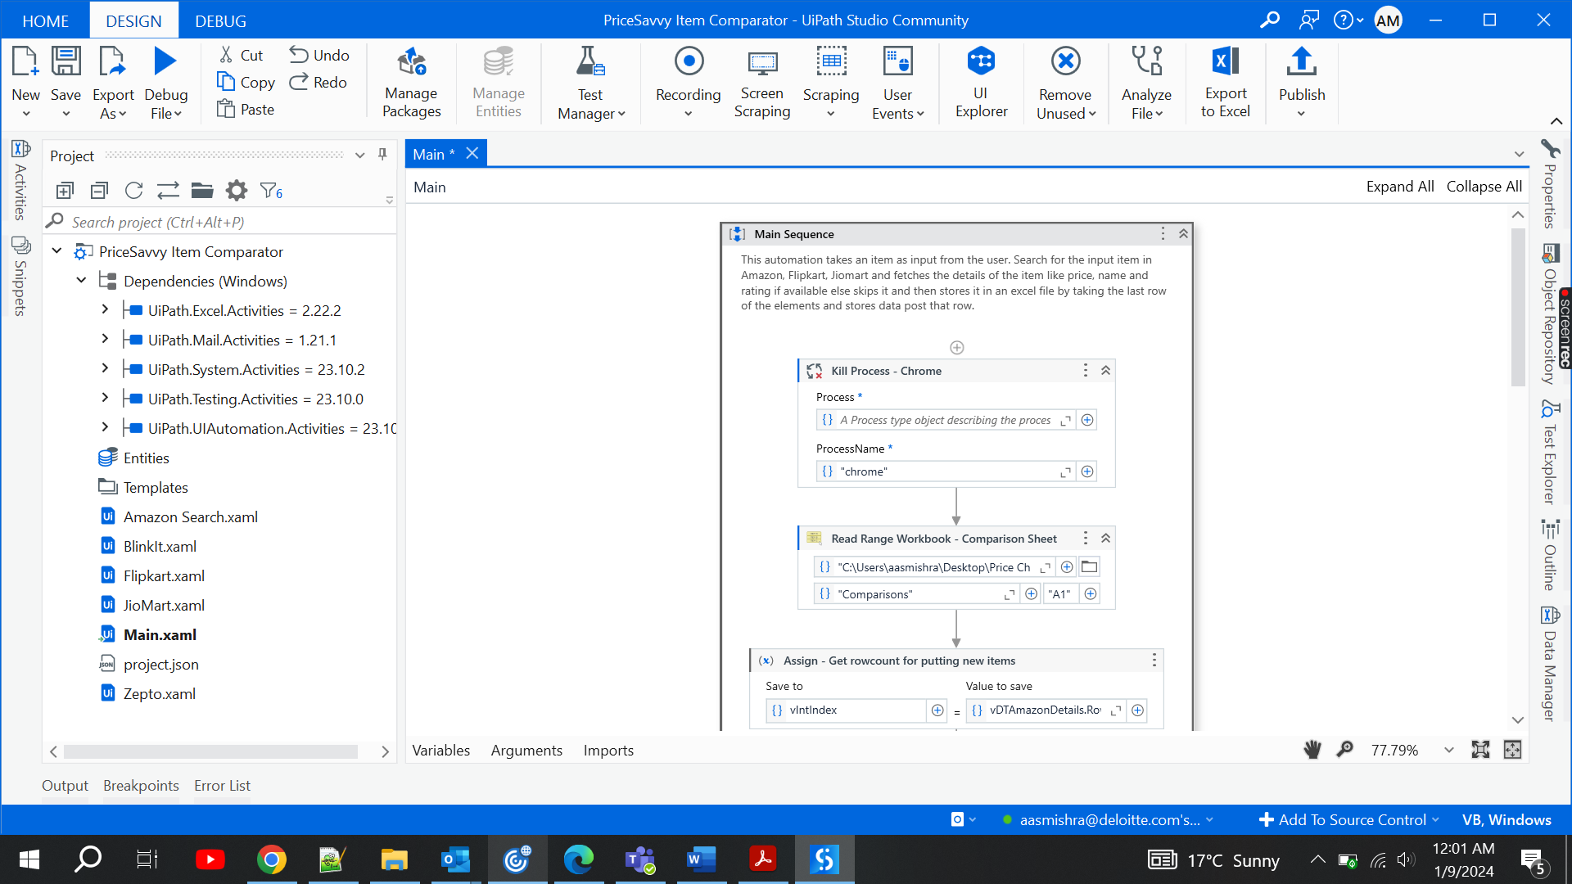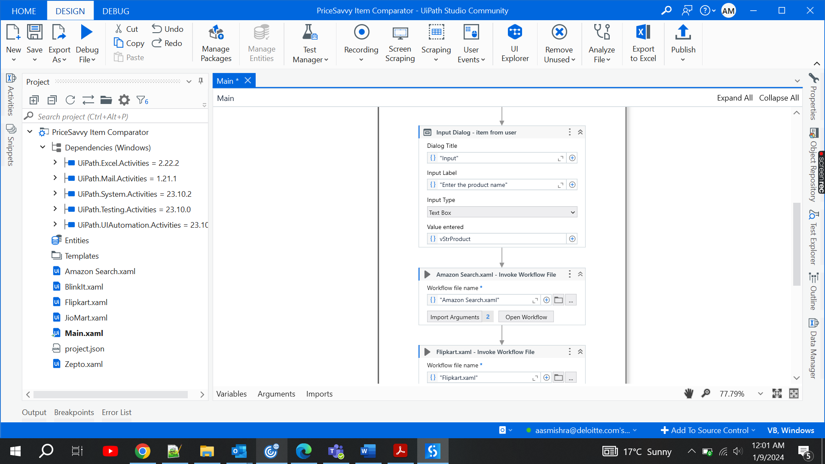 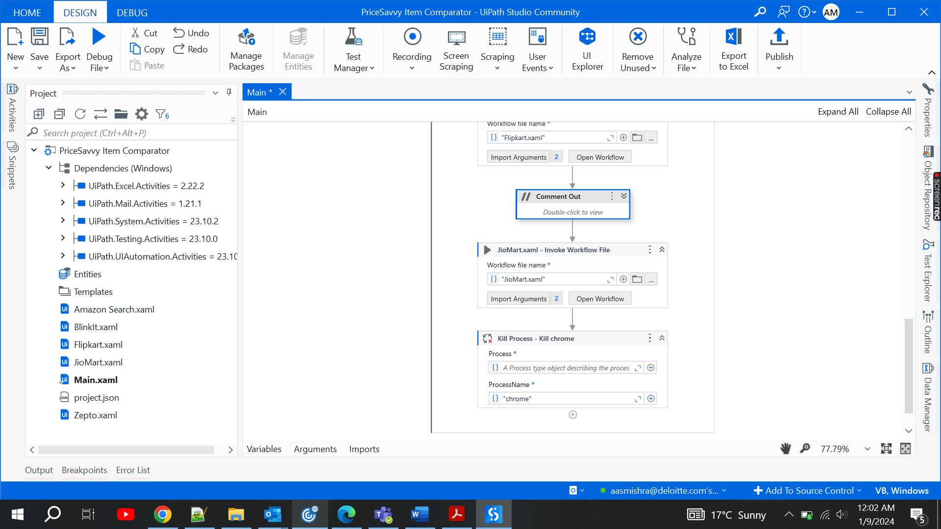



Figure 3.4

**Amazon Workflow:**

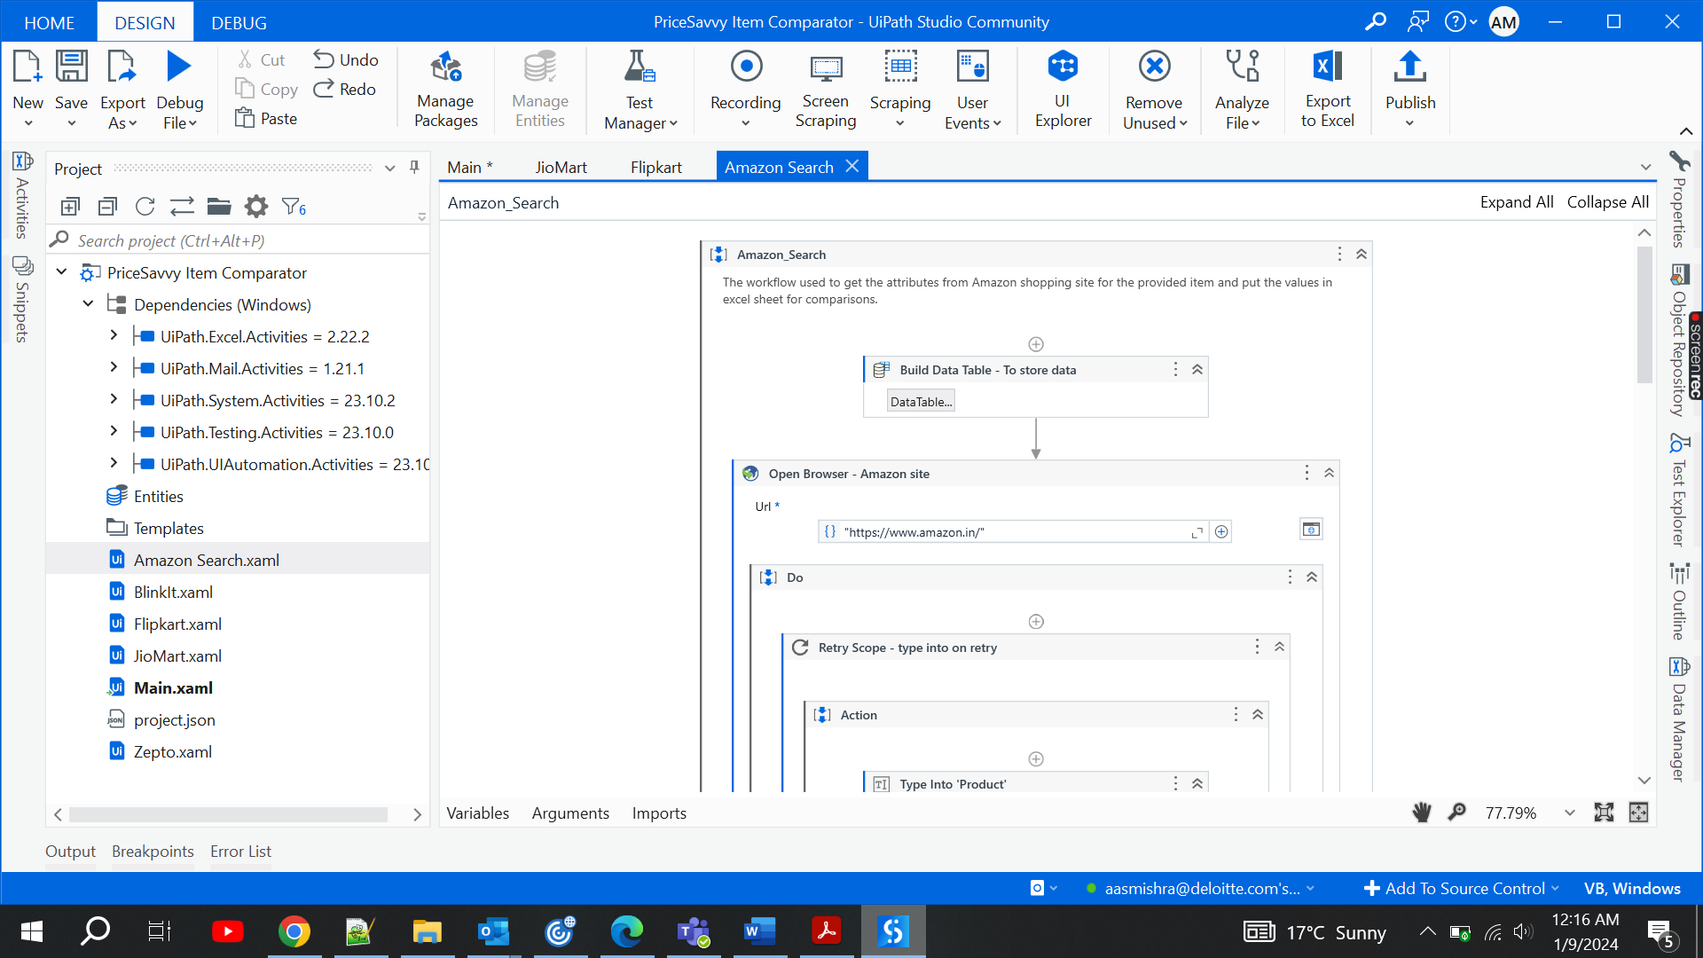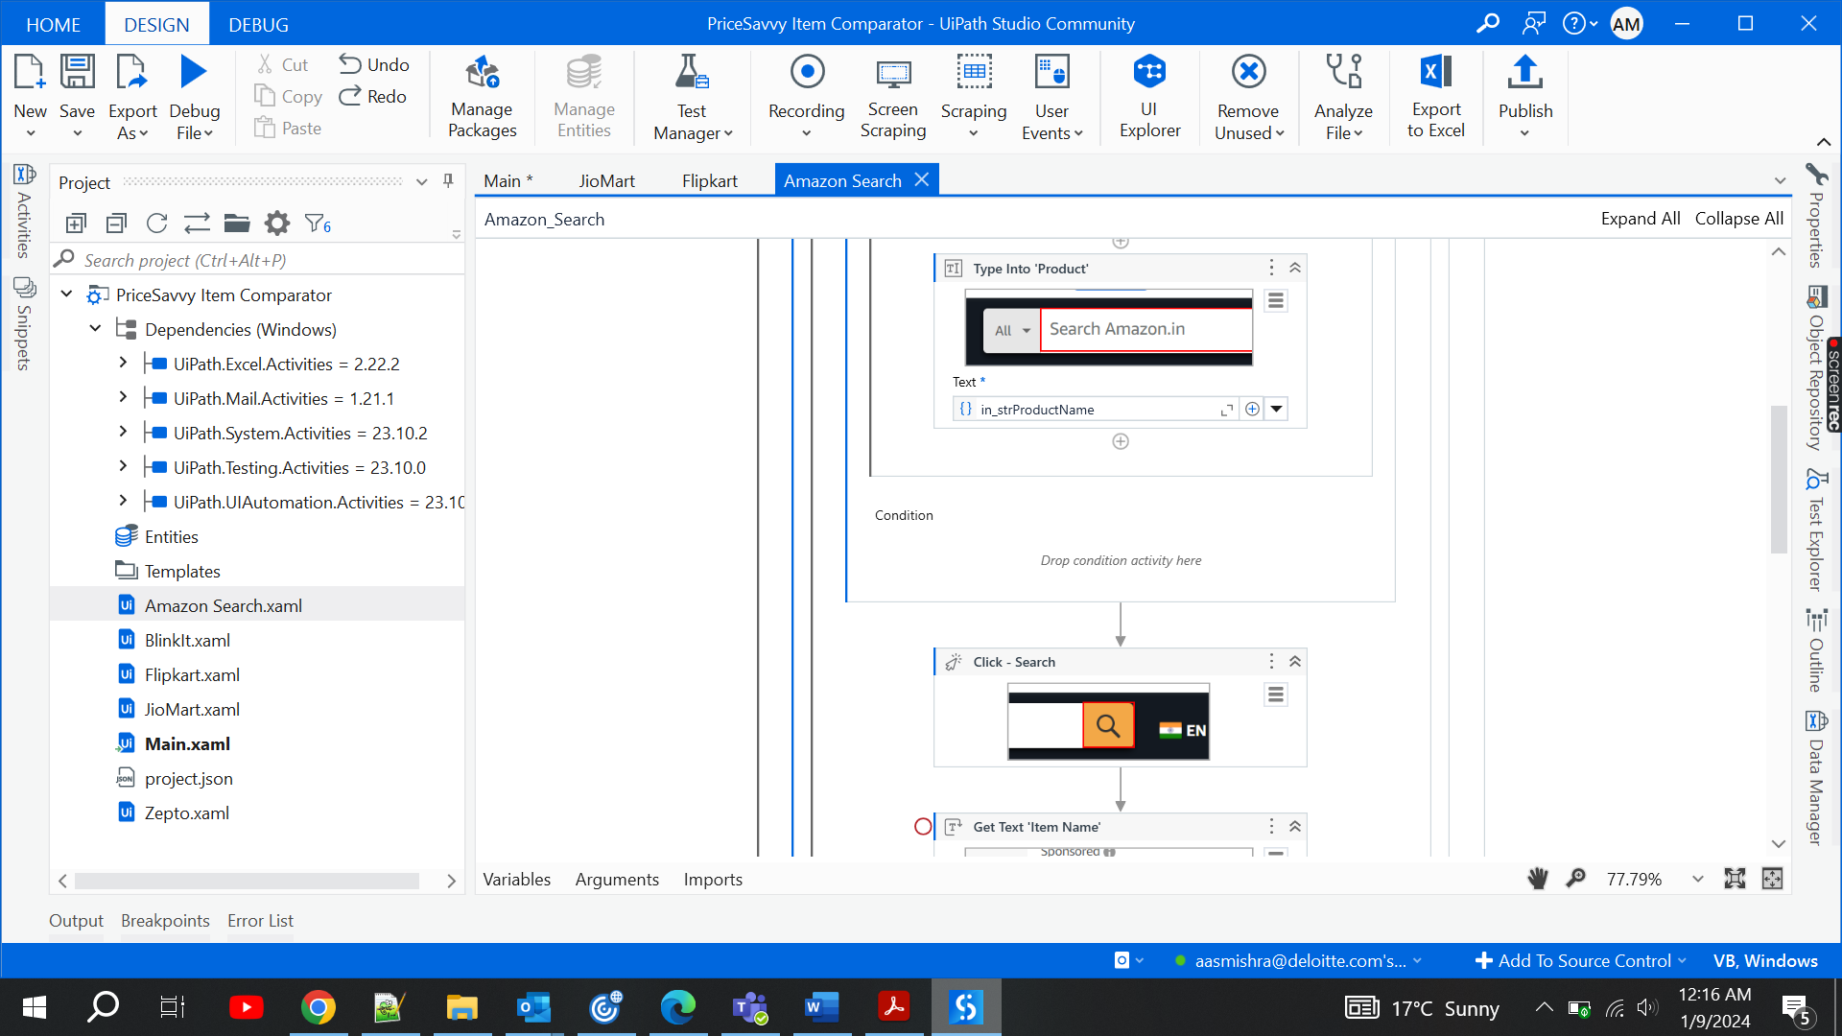

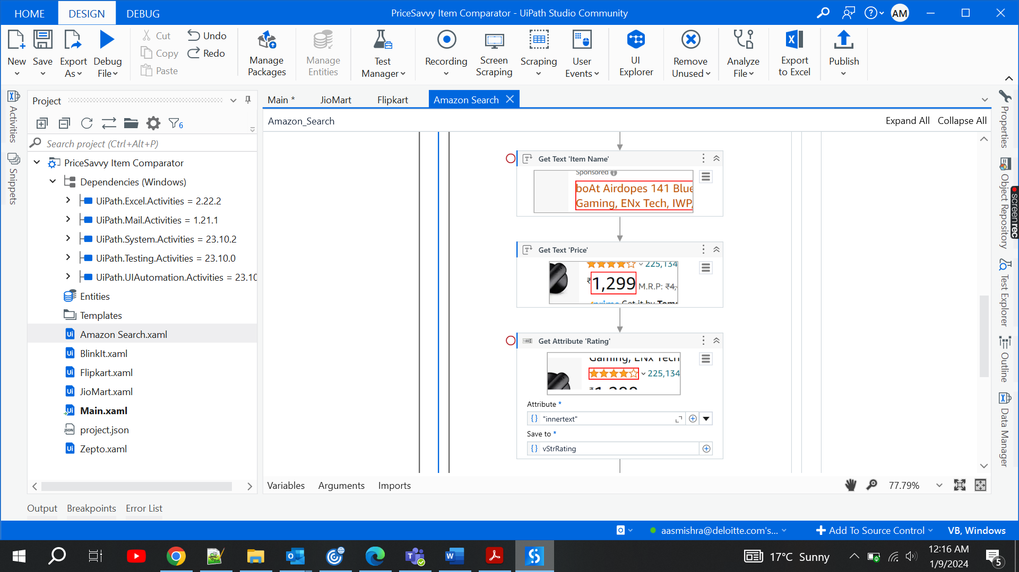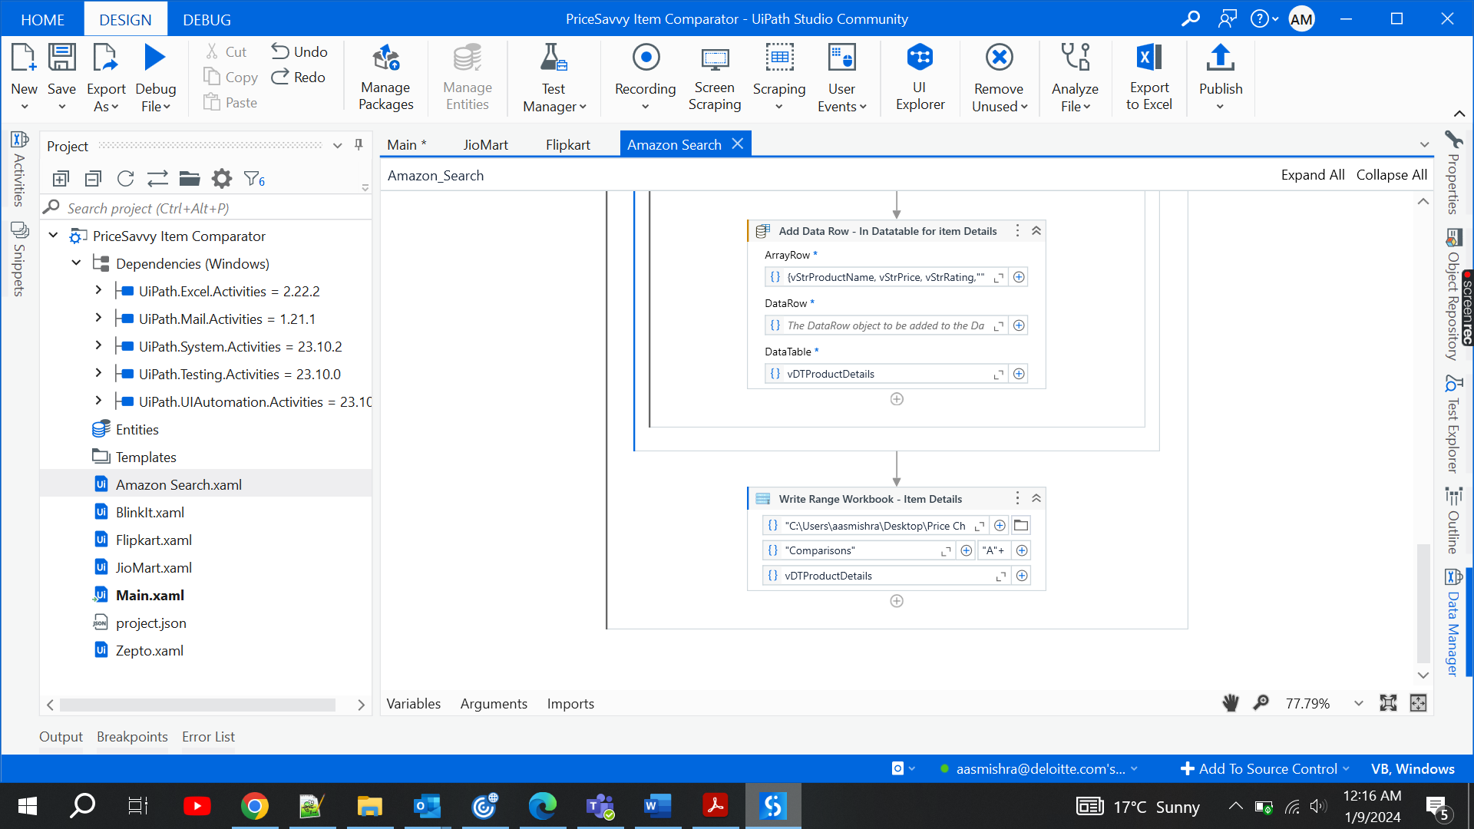Figure 3.5

**Flipkart Workflow:**

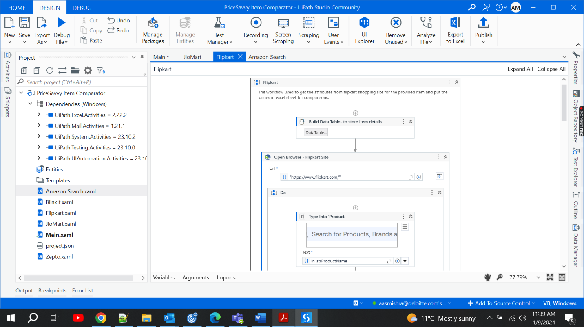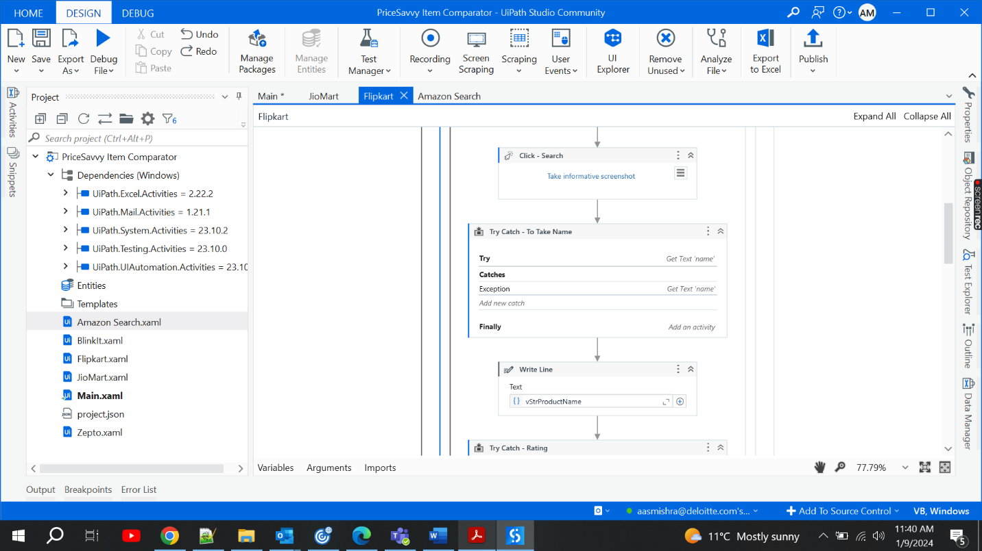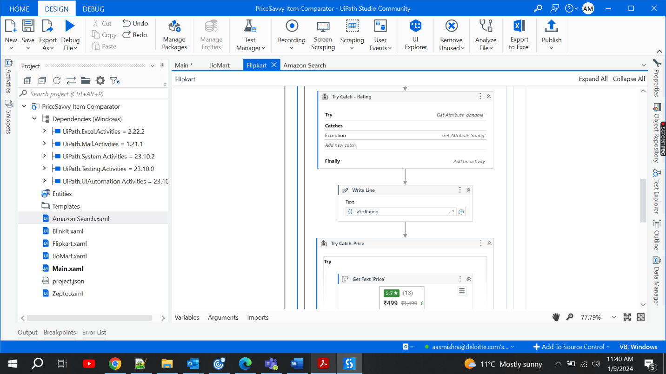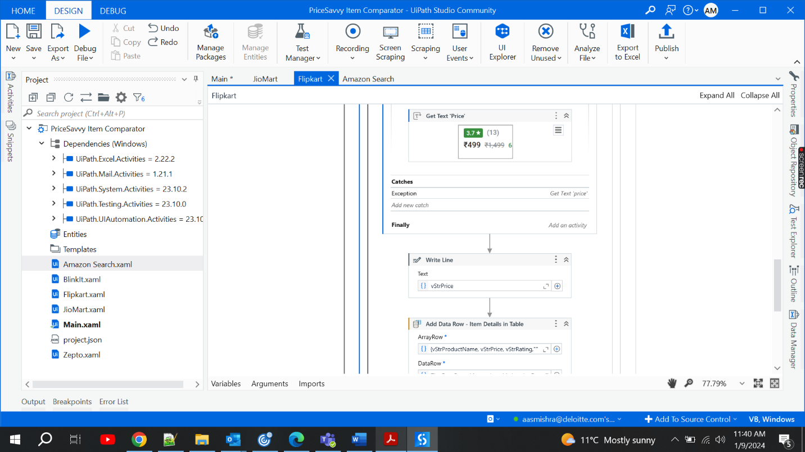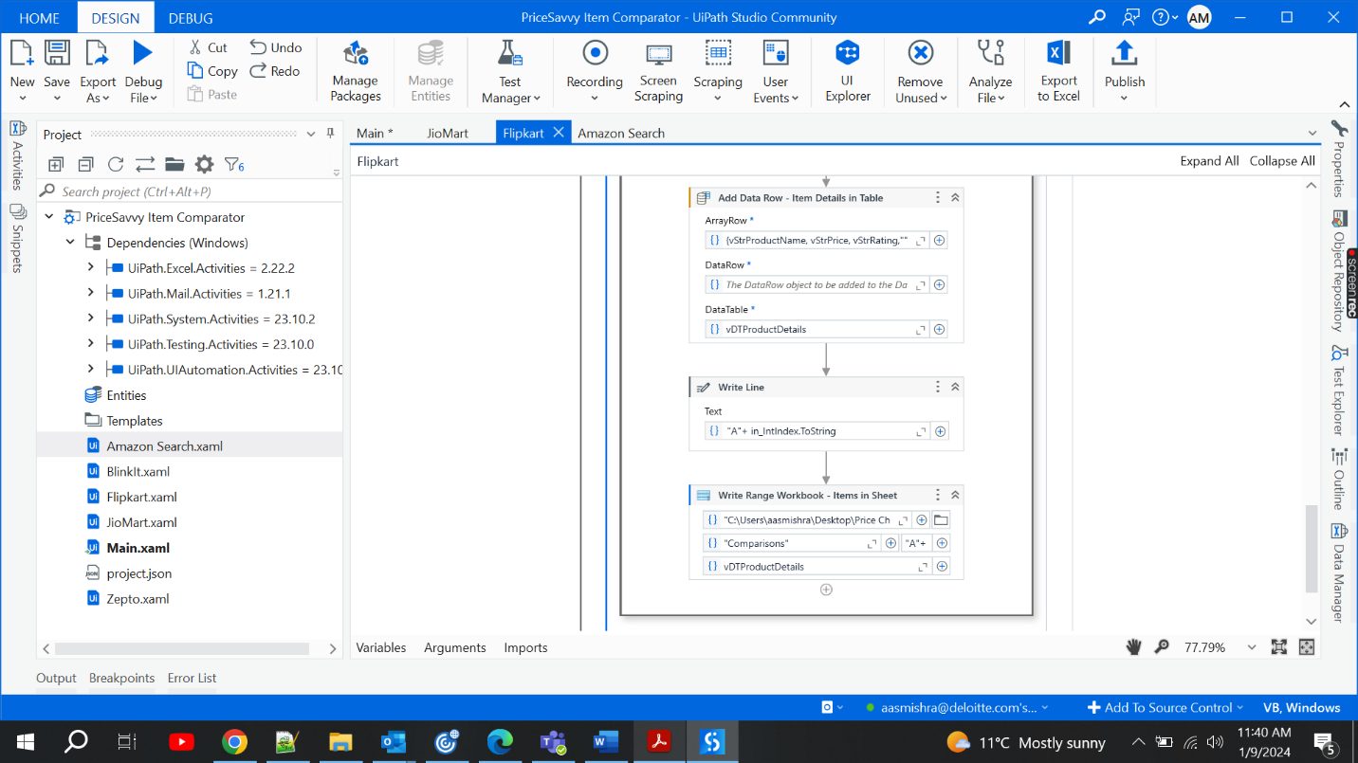

Figure 3.6

**Jiomart Workflow:** 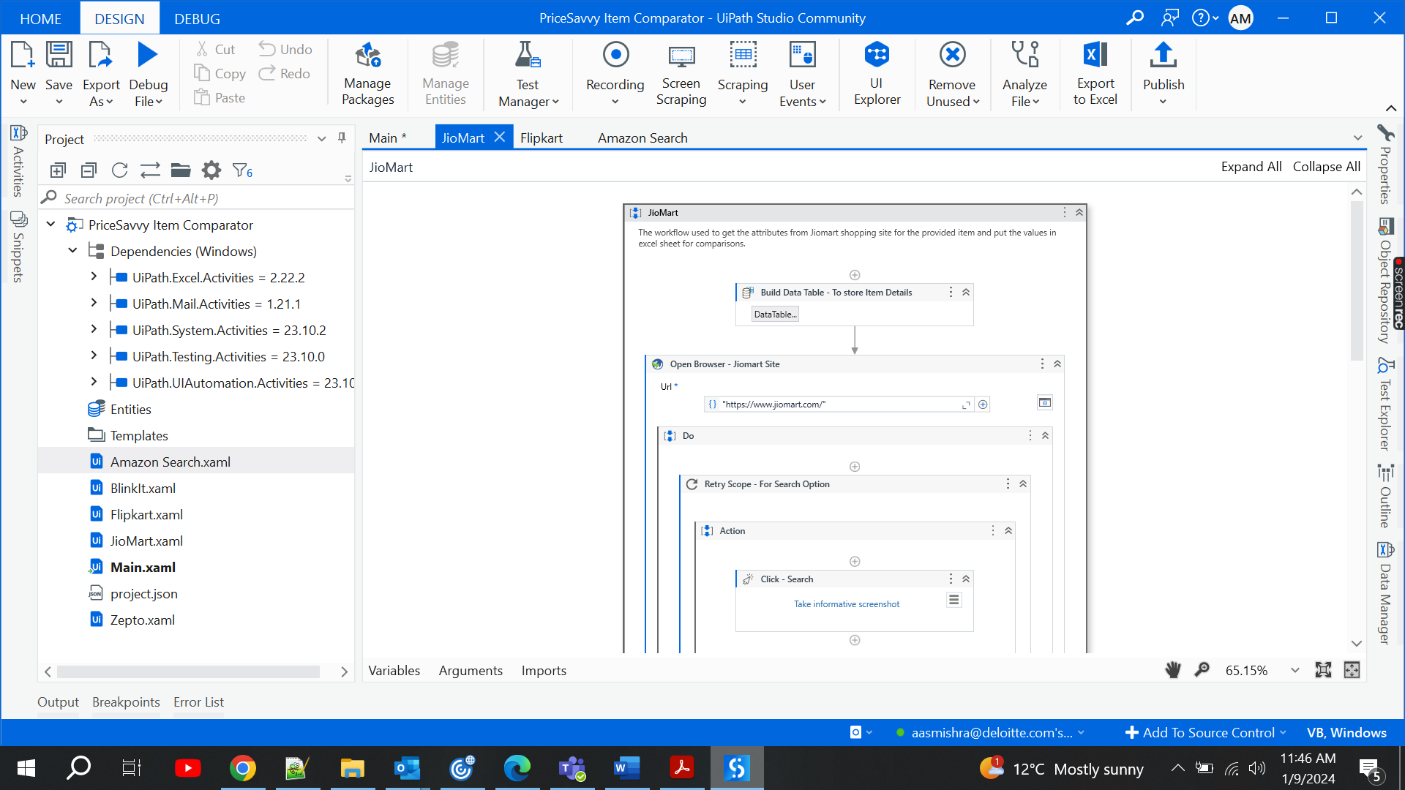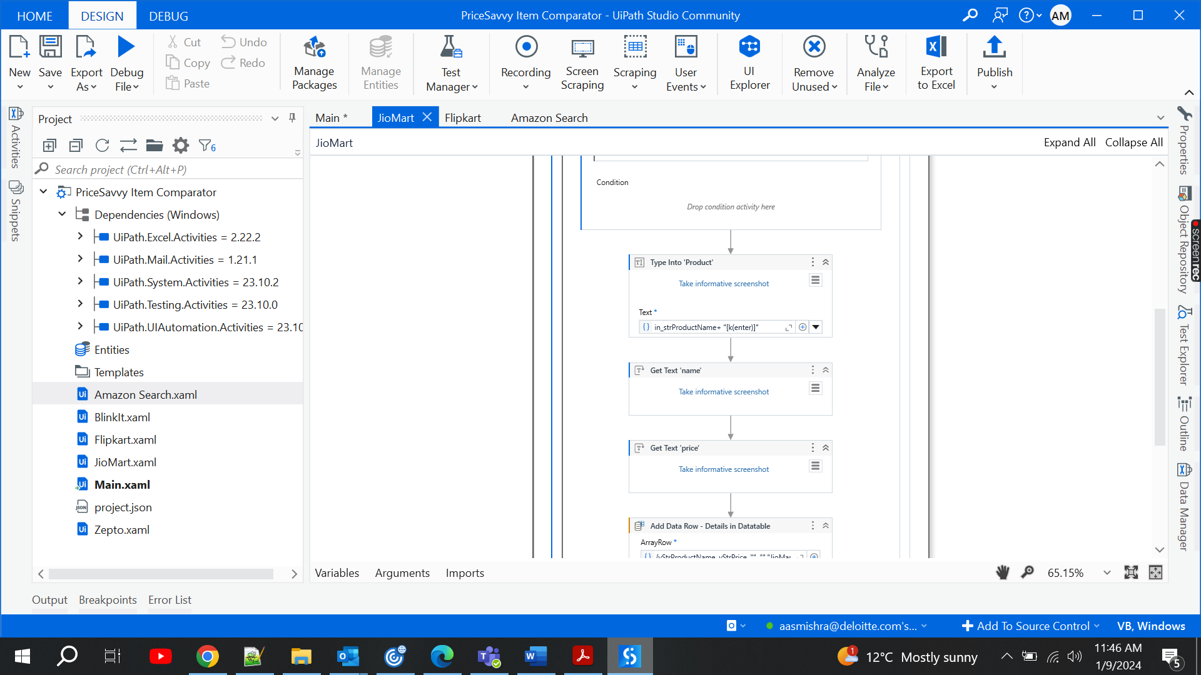

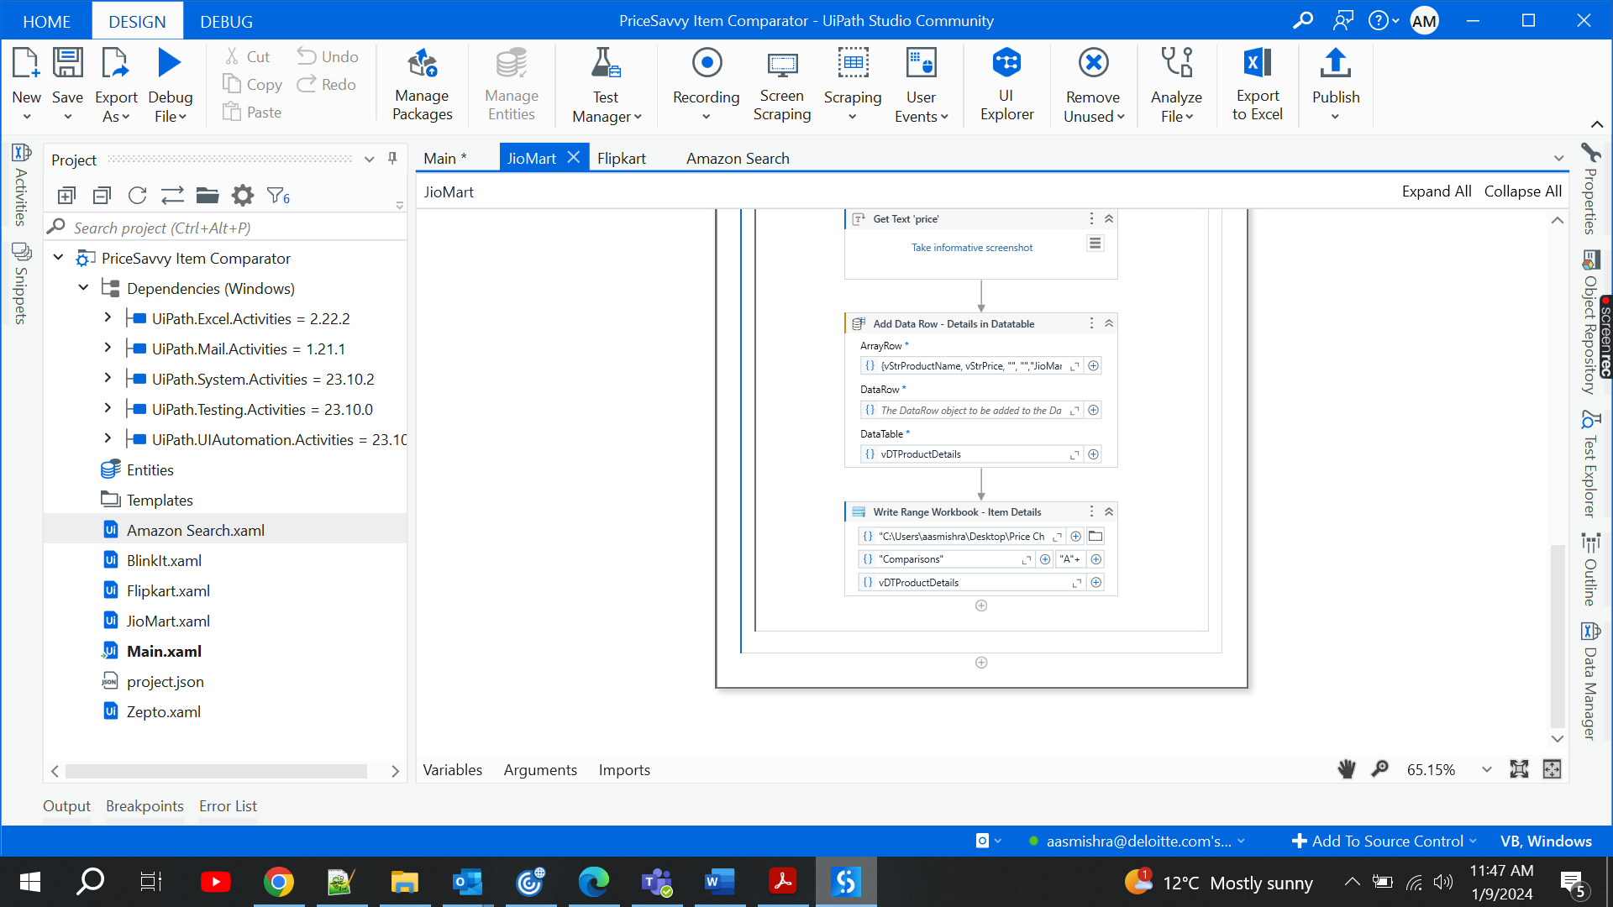Figure 3.7

**LIST OF VARIABLES:**

|  |  |  |  |
| --- | --- | --- | --- |
| **Step** | **Description** | **Input & Output** | **Comment** |
| 1.1 | Main.xaml | Variables:  vStrProduct  vDTAmazonDetails  vIntIndex | * This automation takes an item as input from the user. Search for the input item in Amazon, Flipkart, Jiomart and fetches the details of the item like price, name and rating if available else skips it and then stores it in an excel file by taking the last row of the elements and stores data post that row. |
| 1.2 | Amazon Search.xaml | Arguments:  in_strProductName  in_IntIndex  Variables:  vStrProductName  vStrPrice  vStrRating  vStrQuantity  vDTProductDetails | * The workflow used to get the attributes from Amazon shopping site for the provided item and put the values in excel sheet for comparisons. |
| 1.3 | Flipkart.xaml | Arguments:  in_strProductName  in_IntIndex  Variables:  vStrProductName  vStrPrice  vStrRating  vStrQuantity  vDTProductDetails | * The workflow used to get the attributes from Flipkart shopping site for the provided item and put the values in excel sheet for comparisons. |
| 1.4 | JioMart.xaml | Arguments:  in_strProductName  in_IntIndex  Variables:  vStrProductName  vStrPrice  vStrRating  vStrQuantity  vDTProductDetails | * The workflow used to get the attributes from Jiomart shopping site for the provided item and put the values in excel sheet for comparisons. |

**Naming Convention:**

|  |  |  |
| --- | --- | --- |
| **Object Name** | **Naming Convention** | **Example** |
| Workflow | System/ApplicationAction.xaml | SAPLogin.xaml |
| Activity | **DefaultName - Action Description | IF - Check Status |
| Type Into - Username Field |
| Assign - Increment Counter |
| For Each - Loop on Vendor List |
| Click - Login Button |
| Selectors | **Be sure to remove any Environment/Used related info from Title. |  |
| Variables | vDatatypeName | vStrCustomerName |
| vIntIndex |
| vBoolError |
| vDicConfig |
| vDTNotifications |
| Arguments | arg{In/Out/IO}DatatypeName | argInStrLocationName - where In - Input, Out- Output and IO-Input & Output |
| argInIntRetryNumber |
| argOutStrComment |

**RETRY SCOPE ACTIVITY:**

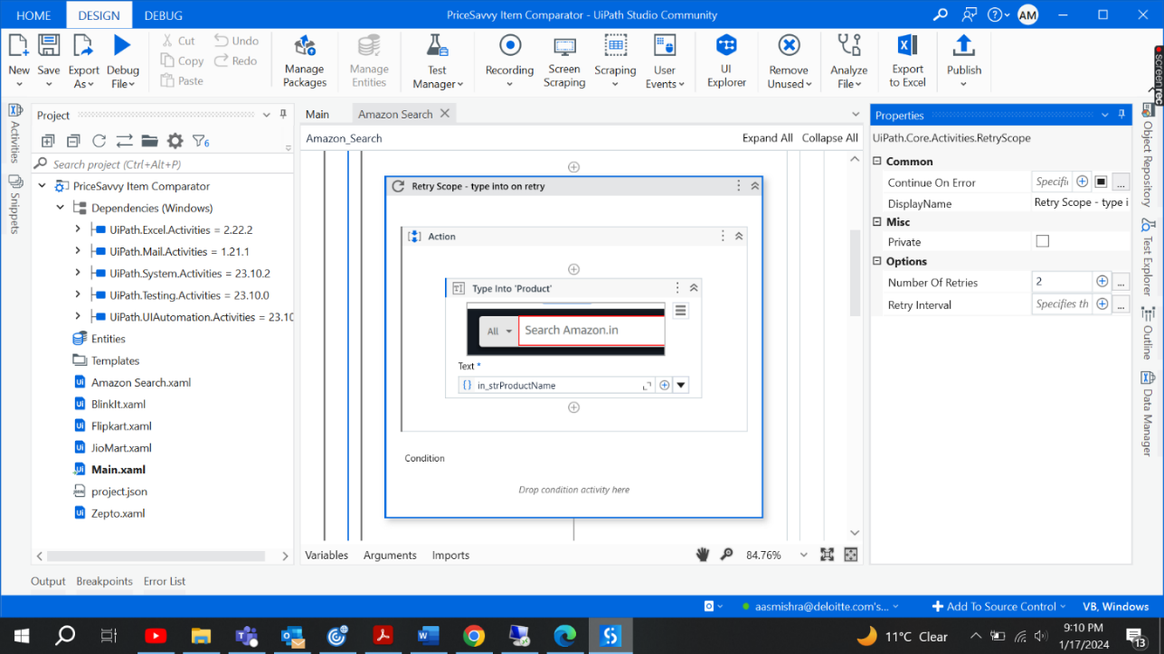

Figure 3.8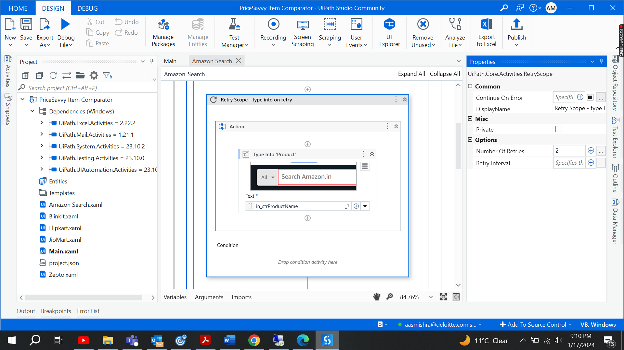

Figure 3.9

Used the retry scope to retry a particular activity i.e., enclosed within the scope. Here we are retrying on the Product type into activity. Bot will make first effort to type the item for the first time and by default will wait for 30 milliseconds, if not typed by that time will retry to type and we have defined two counts for the retry.

**TRY CATCH ACTIVITY:**

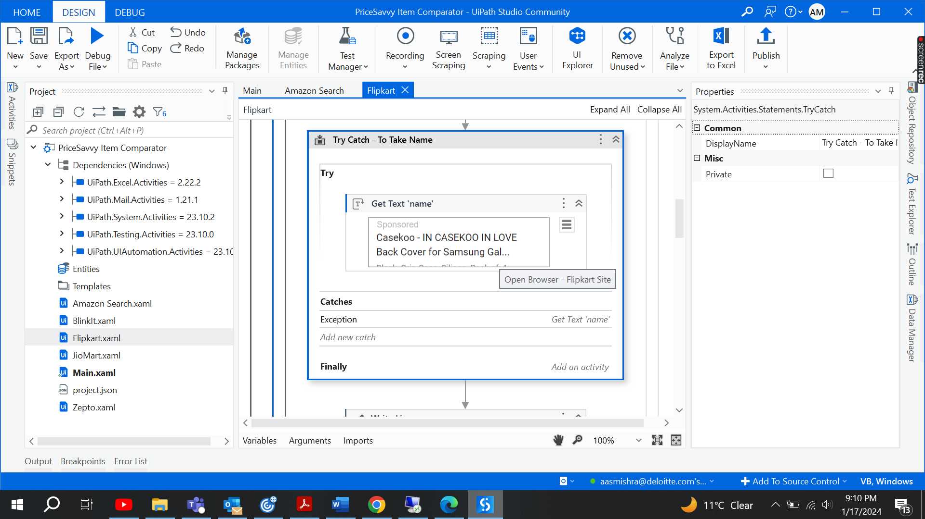

Figure 3.10



Figure 3.11

We have used the Try Catch Activity on a particulat Data Scraping Activity- Get Text Activity which is scrapping the Name of the item from the shopping site.

The aim of using the try catch here is check on a selector is the layout of page is matching with the try activity bot will fetch the name with it else bot will face a system exception, will be routed to the catch block and will try with the new selectors.

**E. Field Settings:** Conducted user testing to ensure the system functions as expected in real-world scenarios. Gathered feedback for improvements.

**F. Testing:**

**1. Unit Testing:** Test individual components (user input, web scraping, data comparison) for correctness.

**2. Integration Testing:** Verify the seamless integration of all components.

**3. User Acceptance Testing:** Allow end-users to test the system and gather feedback.

**G. Implementation:** Deploy the automated system in the intended environment.

**Chapter-4: Results and Discussions**

**1. User Input and Interaction:**

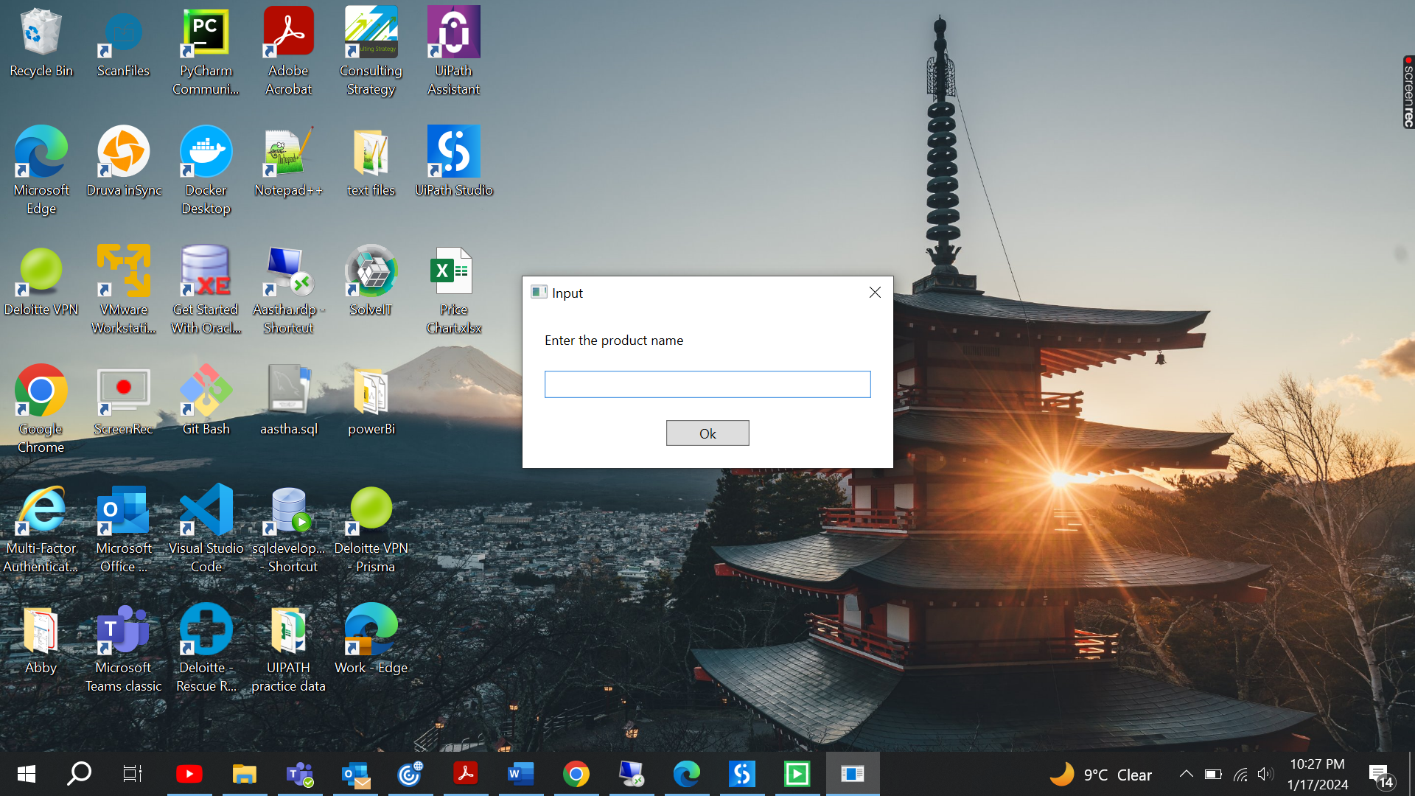

Figure 5.1

Bot takes the input of the product name from the user on running.

**2. Web Scraping and Data Extraction:**

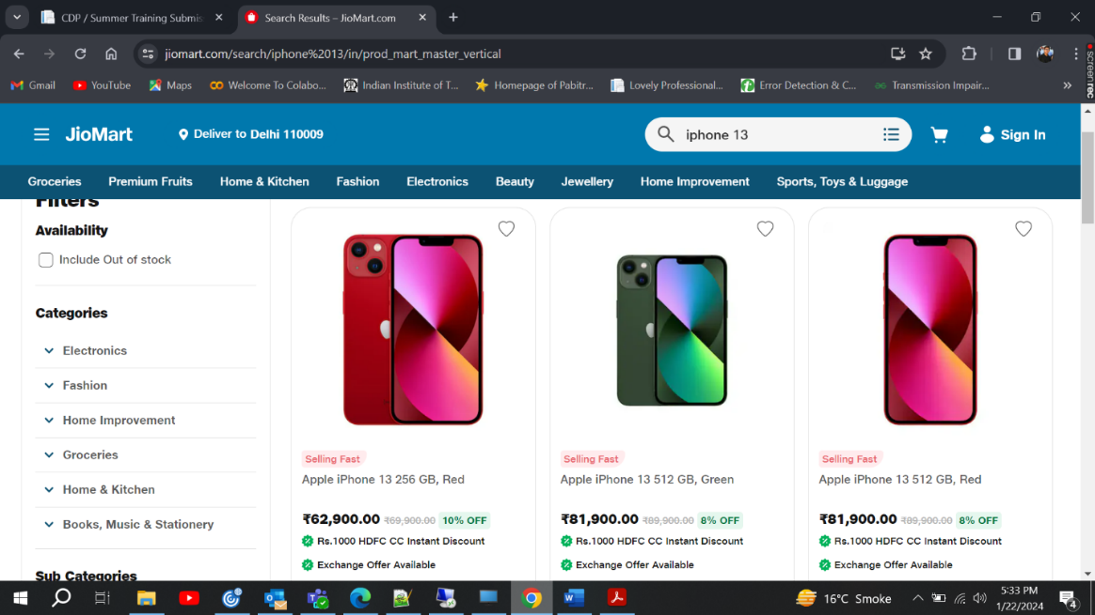

Figure 5.2

Bot will search for the inputted item in the shopping sites. In Figure 5.2, JioMart site is opened. Here Bot will be fetch the latest product name with the price associated with it to store in the excel.

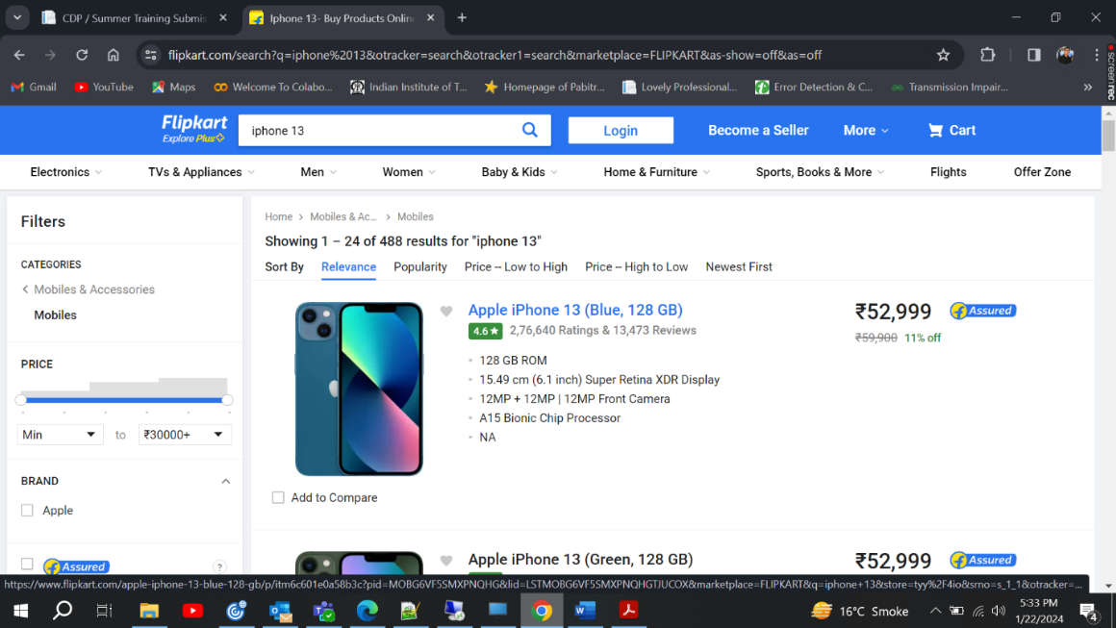

Figure 5.3

In Figure 5.3, Flipkart site is opened. Bot will search for the inputted item in the shopping sites. Here Bot will be fetch the latest product name, ratings and the price associated with it to store in the excel.

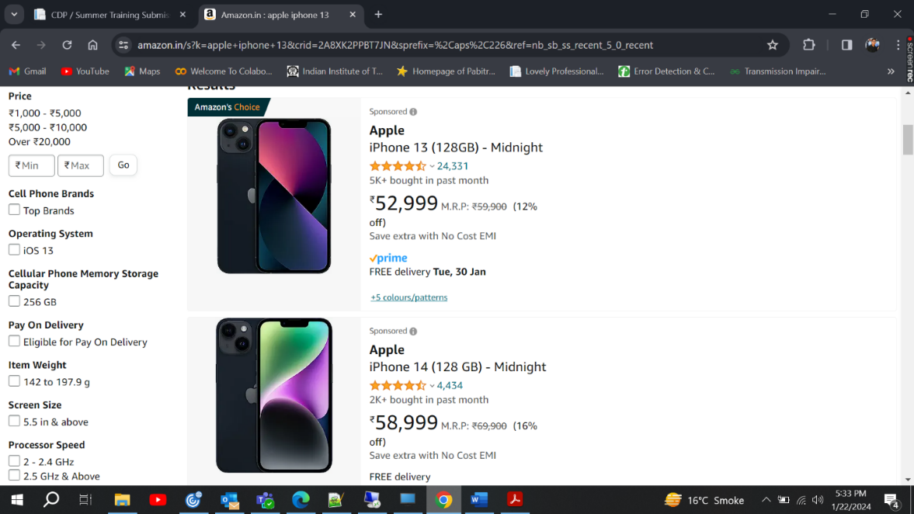

Figure 5.4

In Figure 5.4, Amazon site is opened. Bot will search for the inputted item in the shopping sites. Here Bot will be fetch the latest product name, ratings and the price associated with it to store in the excel.

**4. Excel Sheet Output:**

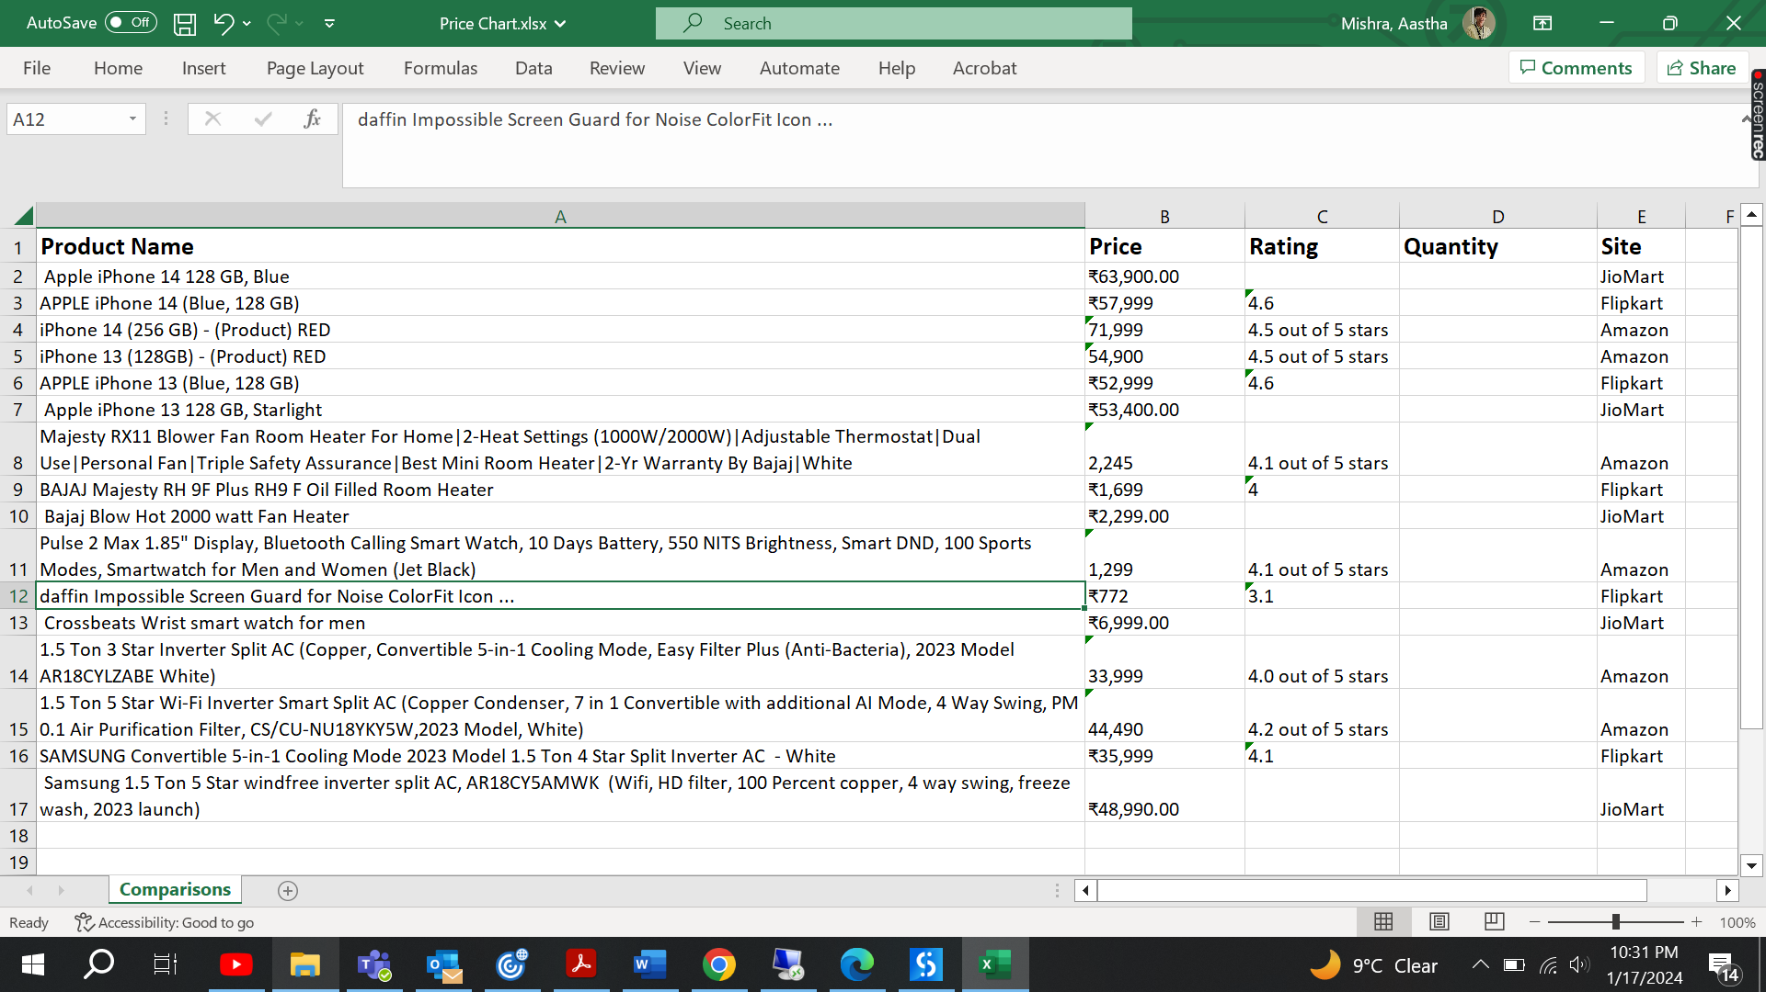

Figure 5.5

In Figure 5.5, we can see the screenshot attached of the excel file ‘Price Chart.xlsx’. Bot will fill up all items fetched details in this sheet. Bot will append the rows of newly searched items.

**DISCUSSIONS:**

**I. Accuracy and Reliability of Web Scraping:**

Web scraping, while a powerful technique for extracting data from websites, comes with its own set of limitations and potential issues. Some of these include:

1. **Website Structure Changes:** Websites often undergo updates and redesigns, leading to changes in HTML structure, CSS classes, or identifiers. This can break the existing web scraping code, requiring frequent updates to maintain functionality.

2. **Legal and Ethical Concerns:** Web scraping may violate the terms of service of a website. Some websites explicitly prohibit or limit automated access to their content. It's essential to review and comply with the website's terms of use to avoid legal consequences.

5. **CAPTCHAs and Anti-Scraping Measures:** Websites may employ CAPTCHAs or other anti-scraping measures to detect and block automated bots. Overcoming these obstacles can be complex and may require the integration of additional tools or services.

6. **Data Quality and Integrity:** Web scraping depends on the structure and quality of the HTML content. Inconsistent data formatting or missing information on the website can result in inaccurate or incomplete scraped data.

7. **Dependency on HTML Structure:** Web scraping tools often rely on the HTML structure of a page. Changes in this structure, even minor ones, can lead to parsing errors and data extraction failures.

8. **Maintenance Overhead:** Continuous monitoring and updating of web scraping scripts are required to adapt to changes in website structures. This can incur maintenance overhead and make the process more time-consuming.

To mitigate these limitations, it's important to stay informed about changes on target websites, use proper techniques and tools, respect website policies, and implement error-handling mechanisms in scraping scripts. Regularly reviewing and updating scraping code is essential to maintain its effectiveness over time.

**II. Comparison Algorithm and Metrics:**

**Algorithms:** Logics are being implemented to fetch the last filled row in the excel sheet and append the data below the last occupied row.

**Selectors: i. Try-Catch:** Inorder to scrap the data from the sites, layout may vary from item to item so try catch activities are implemented to try on the next possible method in the catch block.

**ii. Retry Activity:** To better fetch the data retry scope is implemented on few of the selector activities.

**iii.** Selectors carry properties like simulate click and click only on complete visible and check of complete page load is implemented.

**III. Excel Sheet Management:**

Storing details in an Excel sheet can be effective for certain purposes, but its effectiveness depends on the specific requirements of the task or project. Here are some considerations to analyze the effectiveness of using Excel for storing details:

**Advantages:**

1. **Ease of Use:** Excel is user-friendly and widely used, making it accessible to a large audience. Most people are familiar with its basic functionalities.

2. **Data Organization:** Excel provides a structured way to organize data with rows and columns, making it easy to input, edit, and view information.

3. **Calculation and Analysis:** Excel offers built-in functions and formulas for basic calculations, as well as charts and graphs for data analysis and visualization.

4. **Flexibility:** Excel is versatile and can be customized to suit various needs. Users can create templates, apply formatting, and design sheets based on specific requirements.

5. **Integration with Other Tools:** Excel can be integrated with other Microsoft Office applications and various third-party tools, enhancing its functionality and compatibility.

6. **Data Validation:** Excel allows users to set up data validation rules, helping maintain data accuracy and consistency.

7. **Filtering and Sorting:** Users can easily filter and sort data to find specific information, making it efficient for data retrieval.

**Disadvantages:**

1. **Limited Scalability:** Excel may not be suitable for large-scale data storage and complex databases. It can become slow and inefficient as the volume of data increases.

2. **Version Control:** Managing version control in Excel can be challenging, especially in collaborative environments where multiple users are updating the same file.

4. **Dependency on Manual Entry:** Excel heavily relies on manual data entry, which increases the risk of errors and may be time-consuming for large datasets.

5.**Limited Data Relationship Management:** Unlike relational databases, Excel has limitations in managing complex relationships between different sets of data.

6. **Lack of Concurrent Access:** Excel is not designed for simultaneous editing by multiple users, which can lead to conflicts and data inconsistency in collaborative environments.

Excel is effective for small to medium-sized datasets, simple calculations, and individual use like in this Demo Project. However, for more complex data management tasks, larger datasets, and collaborative work, dedicated database management systems or specialized tools might be more suitable. The choice depends on the specific needs and constraints of the project or task at hand.

**Final Chapter: Conclusion and Future Scope**

In conclusion, the successful implementation of the UiPath-based automation project for user data input, cross-platform comparison, and Excel sheet result storage underscores the tangible benefits of robotic process automation (RPA). By leveraging UiPath's capabilities, the project has significantly reduced manual intervention, minimized errors, and streamlined data processing. This successful deployment showcases the potential of RPA in enhancing operational efficiency within the organization.

The project's outcomes affirm the strategic importance of adopting automation technologies to optimize workflows. The seamless integration of UiPath has not only met the immediate project.

**The key accomplishments of the project include:**

**1. User Input Integration:** The successful incorporation of user inputs into the automation process ensures a dynamic and user-friendly experience. Users can easily provide information, initiating the automated workflow.

**2. Web Scraping and Data Comparison:** The utilization of UiPath's web scraping capabilities allowed for the extraction of relevant information from multiple sites. The comparison of data across various sources contributes to informed decision-making.

**3. Excel Automation:** The seamless integration with Excel facilitates the organized storage of results. Automation of data entry into Excel sheets enhances accuracy, reduces manual effort, and ensures data consistency.

**4. Error Handling:** The project includes robust error handling mechanisms to address potential issues during the automation process, ensuring the reliability and stability of the solution.

**Future Scope:**

While the current project has achieved its objectives, there are several avenues for future enhancements and expansions:

**1. Advanced Data Analytics:** Integrate advanced analytics tools to analyze the stored data, providing insights and trends that can inform decision-making processes.

**2. Machine Learning Integration:** Explore the integration of machine learning algorithms to enhance the system's ability to intelligently process and interpret data, improving accuracy and efficiency over time.

**3. Enhanced User Interface:** Develop a more sophisticated and user-friendly interface for input and output, incorporating graphical elements and interactive features to enhance the overall user experience.

**4. Integration with External APIs:** Extend the project's capabilities by integrating with external APIs, enabling real-time data retrieval and updates from external sources.

**5. Scalability:** Ensure that the solution is scalable to accommodate an increasing volume of data and user inputs, adapting to the evolving needs of the users and the organization.

**6.** **Customizable Automation Workflows:** Develop a modular and customizable automation framework using UiPath's REFramework, allowing for easy adaptation to changing requirements without extensive reconfiguration.

**7. Performance Monitoring and Logging:** Implement robust logging and monitoring mechanisms to track the performance of automation processes, allowing for proactive issue resolution and performance optimization.

In conclusion, the UiPath automation project has provided a solid foundation for further exploration and development. By incorporating these future enhancements, the system can evolve into a more sophisticated and comprehensive solution, meeting the growing demands of automation in various domains.

**References**

1. URL Reference:

a. <https://docs.uipath.com>

1. <https://en.wikipedia.org/wiki/UiPath>
2. Journal Reference:

Lucija Ivančić , Dalia Suša Vugec, Vesna Bosilj Vuksic, ‘Robotic Process Automation: Systematic Literature Review’, ResearchGate, 2019, pp.2-17.